Getting the rotation from driving a circle

Get the latest bagfile name

Confirm the directory the bagfile is in (e.g. /home/ubuntu/.ros/bagfiles)

Get the latest bagfile name (e.g. 2021-09-26-17-40-23.bag)

Download the bagfile to the laptop

To start: $ rosrun plotjuggler plotjuggler

Select “Data” and select the bagfile

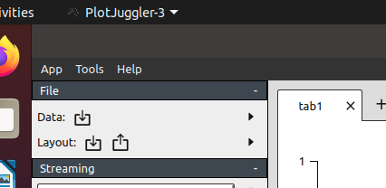

To plot odom x and y

Add a tab 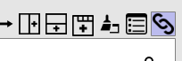

Open or add odom, x & y 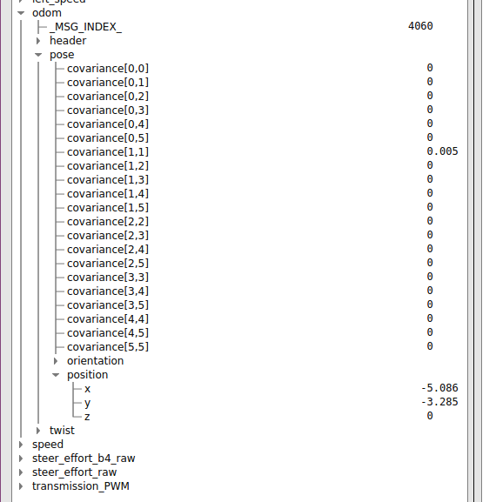

Select “x” then hold the left mouse button down and select “y” 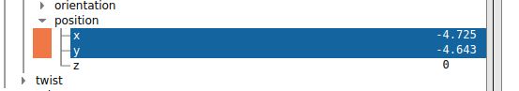

Using the right mouse button, drag the two on to the new tab; A “new X Y curve” window will appear.  
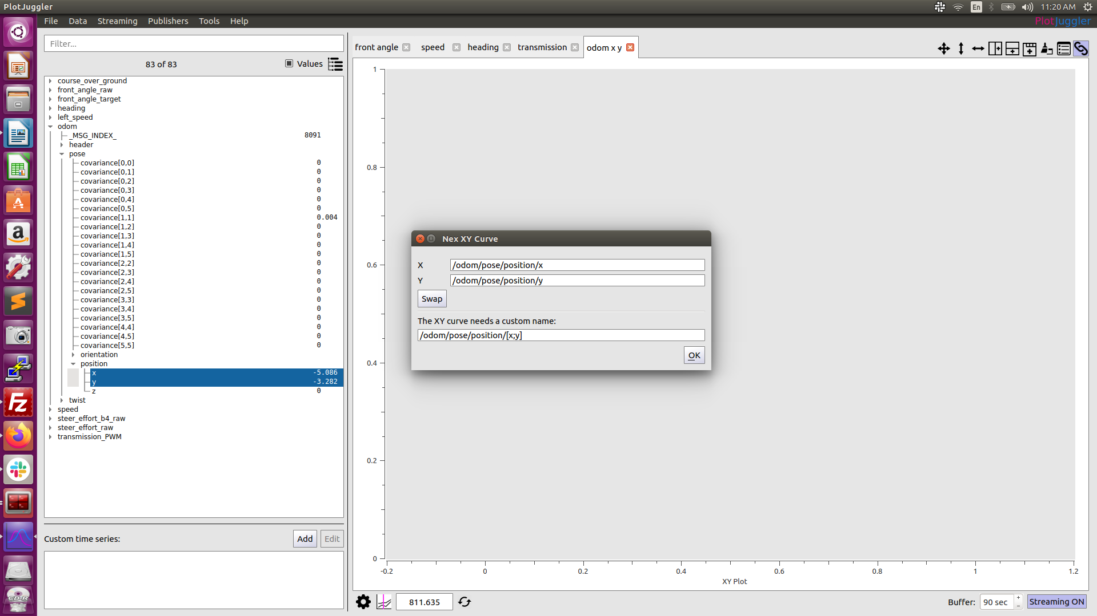

Click OK

Make tabs for the following

